**ASSIGNMENT 1**

Name: Kulsoom Khurshid

Reg#: Sp20-BCS-044

Course: Topics in Computer Science

Topic:

Digital Diagnostic Lab

Abstract:

There are many life threatening diseases that are related to chest which may affect one or both lungs. Chest X-rays, CT scans and MRI’s are used for diagnosing these diseases in our project. Thus, developing an automatic system for detection would be beneficial for treating diseases without any delay especially in remote areas. In this application, deep learning and machine learning algorithms are used for analyzing medical images and make decision for the correct diagnosis. This application is limited to chest diseases only, which is approximately to 14-15 diseases.

Key Terms:

Machine learning, deep learning, image processing

Modules:

**Machine Learning:**

**Module 1: ml-KNN**

It is a Machine Learning algorithm that is used for prediction. In the application, it would be used for the prediction of the disease.

Installation:

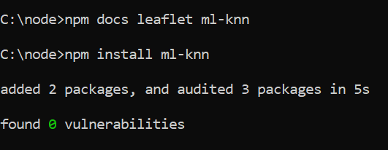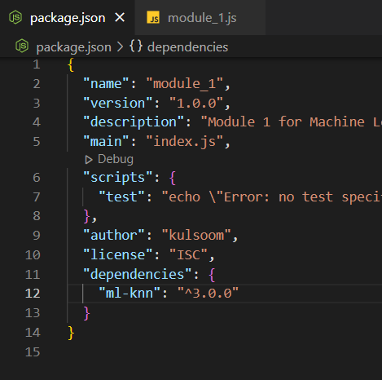

**Module 2: fuzzy.ai**

This logic is used to mimic a person how it will make decision but much faster. It is used with Neural Networks. It is an AI and ML technology used for detecting similarity but not identical elements in the data set.

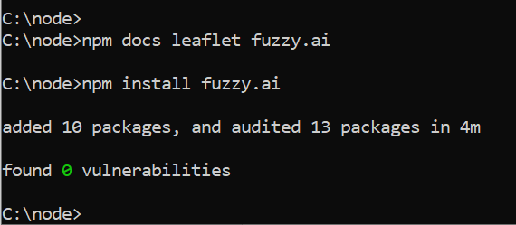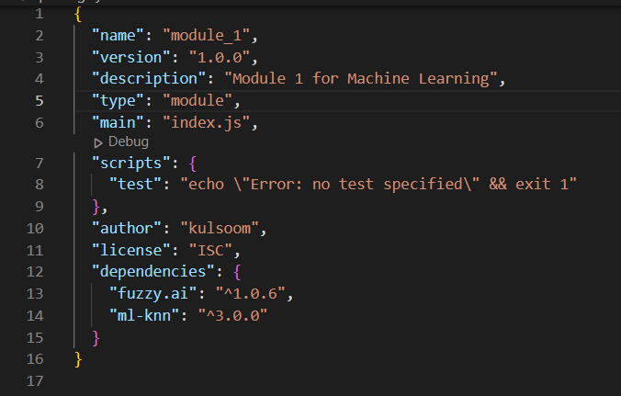Installation:

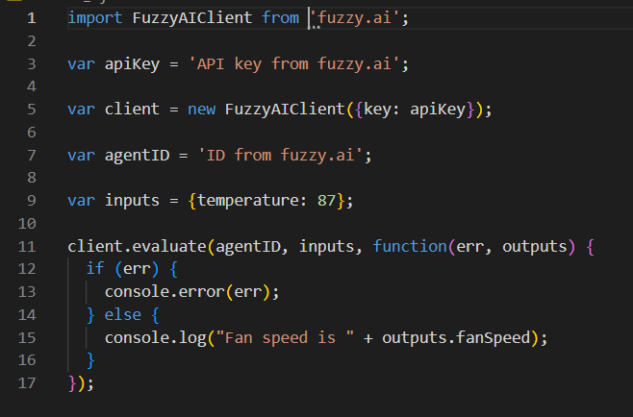

**Module 3: ml-convolution**

This module uses FFT(Fast Fourier Transform) or any other algorithm to train the CNN quickly.

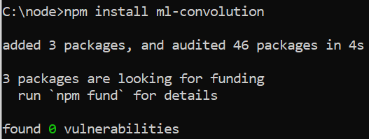Installation

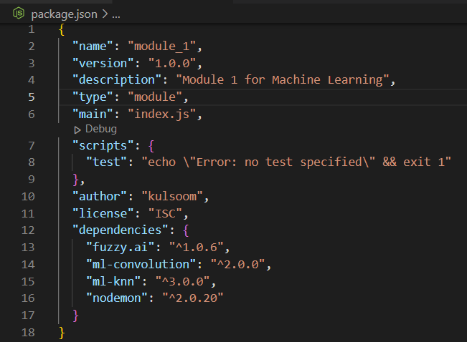

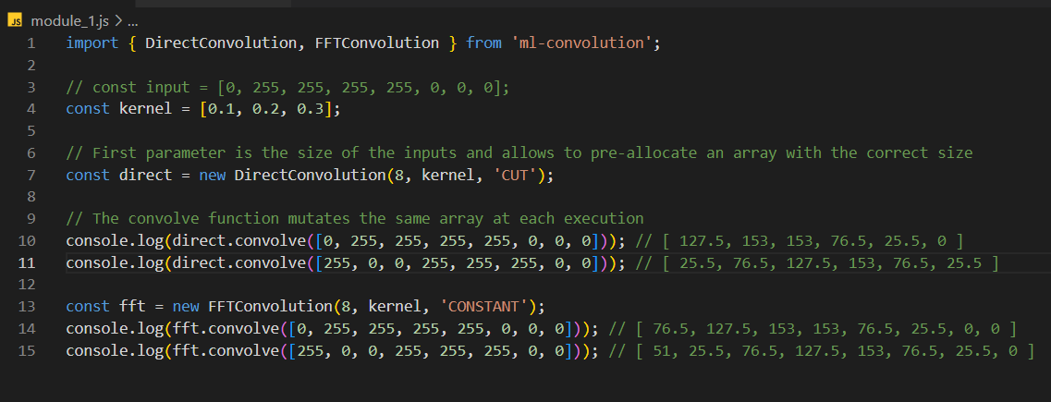

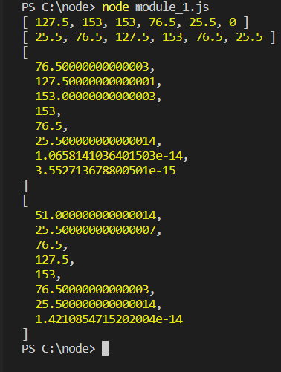

**Module 4: ml-tree-similarity**

It is used to compare the two objects if there is similarity it belongs to same class. In our case, while training the model for projects it defines certain classes. When we give test data, the tree similarity module will compare the data with that of class data and generate the prediction.

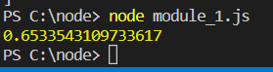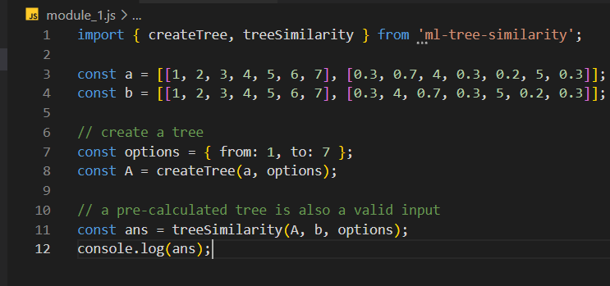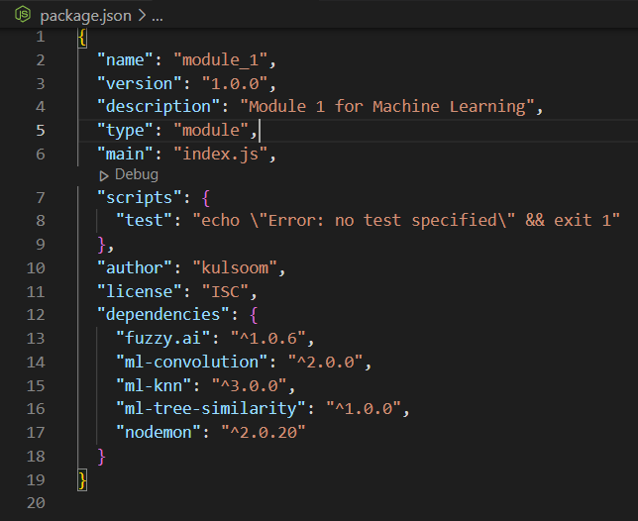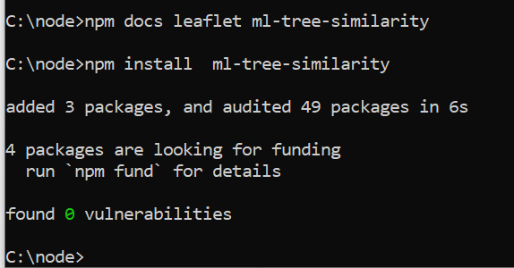Installation

**Image Processing:**

**Module 5: image-filters**

It is used for overturning the high frequency images by smoothing the images or enhancing the low quality images. Image processing is very important for the project as the diseases are detected based on the images.

Installation

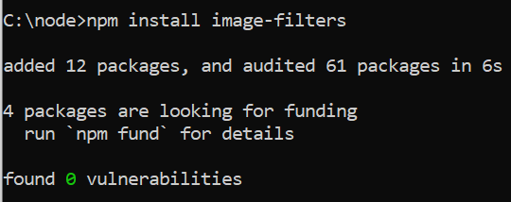 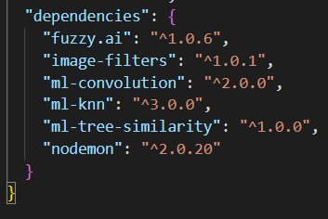

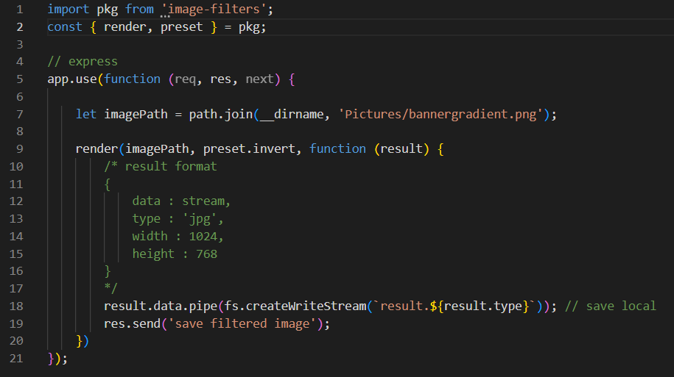

**Module 6: browser-image-compression**

It is used to compress the image to utilize the bandwidth. Compression is done before the image is uploaded to the application server.

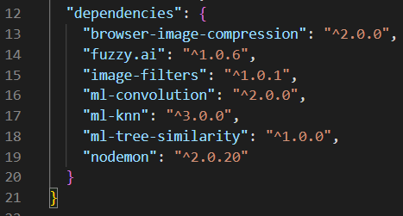Installation

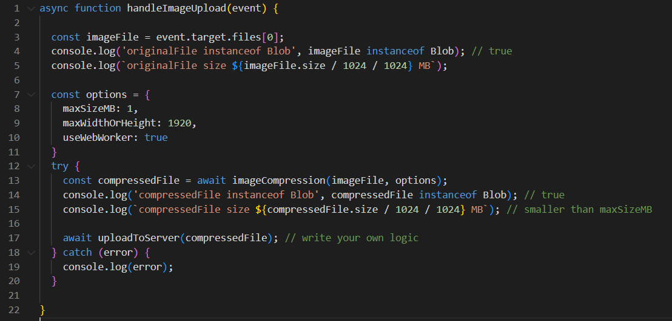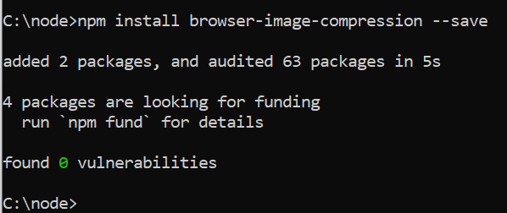

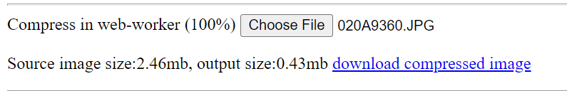

**Module 7: deeplearning-js**

It is an open source library available in js for the users to use for deep learning purposes without learning the complex and unfamiliar python, calculus knowledge.

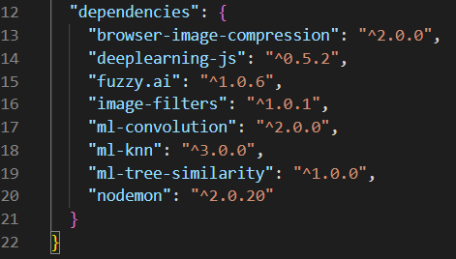Installation

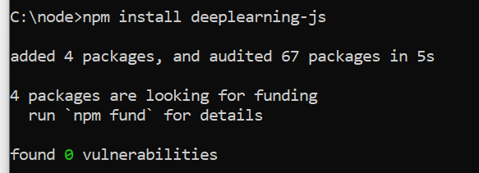

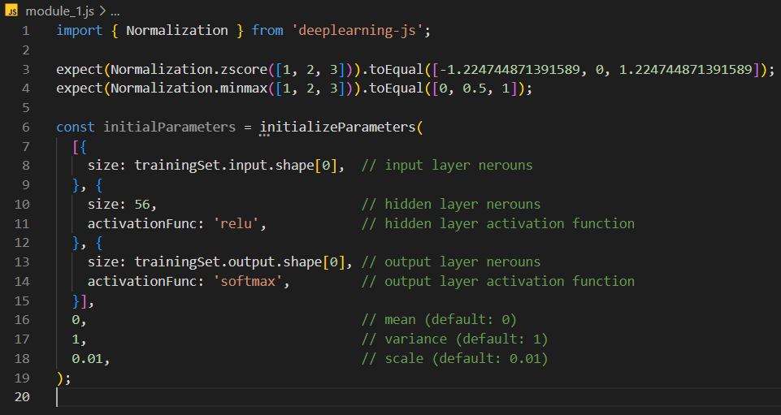

**Module 8: sharp**

It is a library that can convert large images into offenly used formats to reduce the size such as png, jpeg, jpg, etc. Resizing image is 5 times faster than using any graphicMagic settings using libvips.

Installation

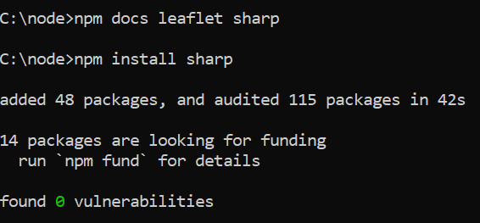 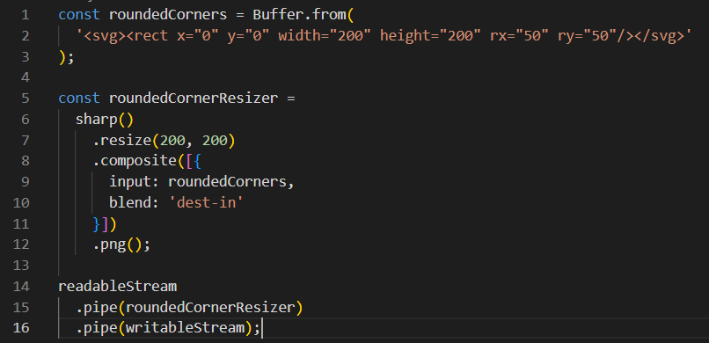

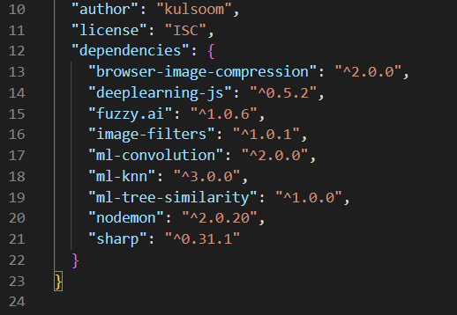

**Module 9: cnn-health**

Keras is used to train CNN and make neural networks implementation easy.

Installation:

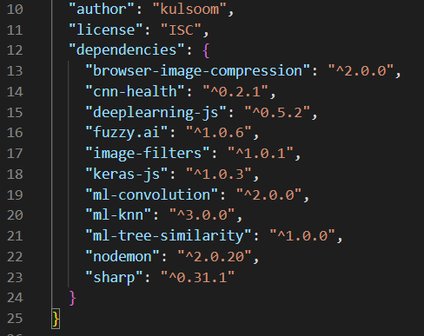

**Module 10: file-type**

It is used for getting the correct file as it only accepts the binary files(pictures) and not text files.

Installation

